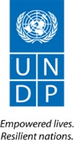
`
Governance for DRR in Kenya Project

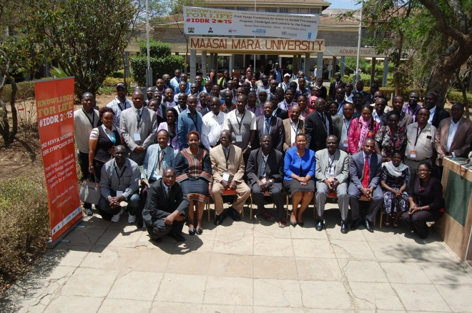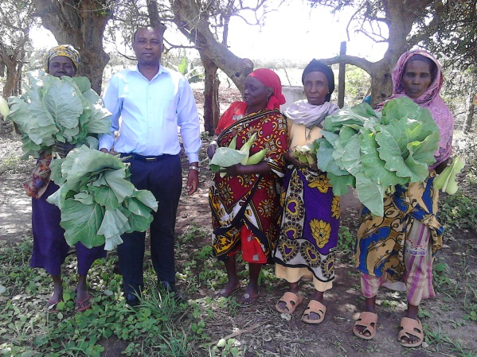
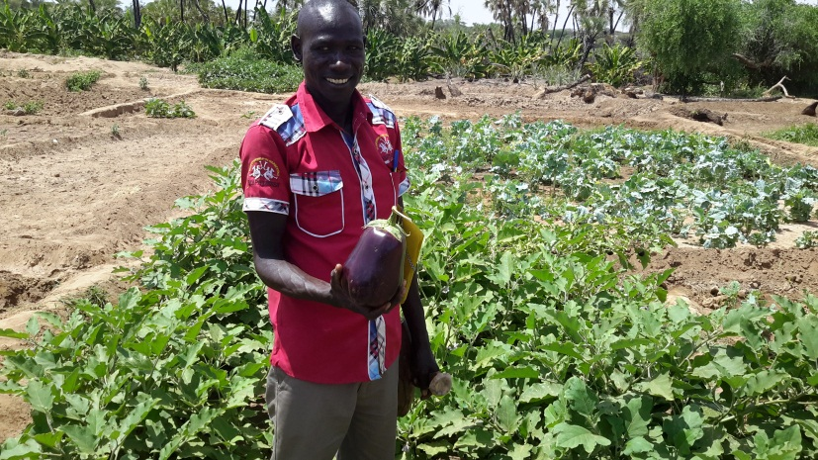
Draft Annual Report | December 31  2015
Draft Annual Report of the GDRR project implemented by the National Drought Management Authority - NDMA |  | January- December 2015

Table of Contents
I. EXECUTIVE SUMMARY 1
II. IMPLEMENTATION RESULTS 5
III. CHALLENGES 5
IV.LESSONS LEARNT SO FAR 5
V PROJECT MANAGEMENT 6

I. EXECUTIVE SUMMARY
The Governance for DRR in Kenya Project is 3-year initiative which has the objective of strengthening institutions responsible for disaster risk reduction both at national and county levels. The project has interventions which cover support to policy enactment, establishment of mechanisms for assessing and monitoring of disaster losses and impacts; support in mainstreaming DRR into government planning and budgeting process; disaster information management systems and partnerships.
The project target group includes government officials at National and County levels and community members. At the national level the target beneficiaries are drawn from the Ministry of Devolution and Planning, Ministry of Interior and Coordination of National Affairs, NDMA, collaborating institutions such as NDOC as well as the technical line ministries. At the county level the target beneficiaries include department’s responsible for disaster management including the County Disaster Management Coordinator; County Assemblies and other Policy makers; County Disaster Management Committees and County Development Planners. The project also builds community level capacities through Community Based Disaster Risk Reduction and enhancing livelihoods resilience at household level.
The objective of the project is to ensure effective Governance for Disaster Risk Reduction at National and County levels.
The expected project outputs are:
- Institutional and legislative capacity for policy formulation and implementation strengthened at national and county levels.
- Capacity to assess and monitor disaster risks and early warning systems strengthened.
- Partnerships and networks for DRR strengthened
- Resilience building through the diversification of livelihoods for drought stricken communities.
- Effective Project Management

As a result of the capacity building interventions, the targeted government officials and county level institutions are now able to better integrate DRR into normal government planning processes as well as address specific disaster risk issues in the counties. In addition, the community members reached during the year now have more diversified livelihoods and economic activities and are thus on pathway to resilience. During the period the project faced various challenges including administrative constraints and insecurity. However these were mitigated to enable implementation to proceed. The activities implemented during the year are detailed in the section below.
Some positive results which are building the resilience of the communities have been felt at community level and it is anticipated the project will achieve its desired outcomes within the planned period.

II. IMPLEMENTION RESULTS:
Output 1: Institutional and Legislative capacity for policy formulation and implementation strengthened at national and county levels
During the period under review, the project implemented various activities which contributed to the achievement of this output. The impacts of the activities implemented are envisioned to improve the capacity of institutions to coordinate DRR activities at the national and county level. The activities implemented are summarized in the section below.

Highlights from the County DRR Capacity Assessment Exercise:
- There is political commitment to DRR within the County Government and the county government is willing to commit resources to DRR/M.
- There is poor coordination of DRM activities at the county level.
- The Counties have made a budget allocation for Disaster Management and emergency funds but poor regulation of the emergency funds.
- No DRR policy within the Counties

Recommendations
- The project should provide technical support to the County for DRM policy formulation ensuring it incorporates best practices from elsewhere.
- Skills enhancement and institutional support for County Government
- Strengthening of County DRR platform so that it should act as a link between communities and the county government to share good practices and influence policy formulation and legislation process.

Activity Result 1.2 Strengthen DRR Institutions at National and County levels
During the reporting period, the project initiated a capacity assessment exercise to map out the status of DRR policy formulation and human capacity of 13 ASAL counties. Through this assessment, the program was able to identify the capacity gaps both technical and in terms of human resource within the Counties. From the recommendations of the assessment, the project was able to enhance the skills of the technical and County government officers who are members of the County DRR platform who will in turn influence policy formulation in the area of DRR.

Activity Result 1.3 Strengthen Co-ordination Structures at all levels
- Strengthen and facilitate the DRR Platform at the national level:

Highlights of the National Platform (NP)
- Official appointment of the Ministerial DRR Focal persons
- Established thematic working groups based on the Sendai priorities for Action for ease of implementation of the National DRR Action Plan .
- Shared the National DRR plan with members of parliament as a way of lobbying and advocating for the enactment of the National DRR policy.

Under this result area, the project organized for two National platform meetings. The first meeting was before the WCDRR conference where the stakeholders discussed Kenya’s participation in the upcoming conference and made recommendation on Kenya’s position during the World Conference in Sendai Japan. Following WCDRR and the adoption of the Sendai Framework for Disaster Risk Reduction, the national platform held its second meeting of the year.
The meeting was attended by the 30 DRR focal points from the government ministries, UN Agencies, NGOs and academic institutions. The platform agreed to engage more strongly with the government the private sector in matters of DRR. In this renewed call, the national platform embarked on developing National DRR Plan of Action based on the Sendai Framework and borrowing from the continuing work of the HFA. The DRR plan for action was shared with the members of parliament as a way of advocating and lobbying for the enactment of the DRR policy. With the onset of the El Nino rains later in the year, the platform members received training on Rapid assessment as they are focal points in response to the effects of disasters in their various ministries.

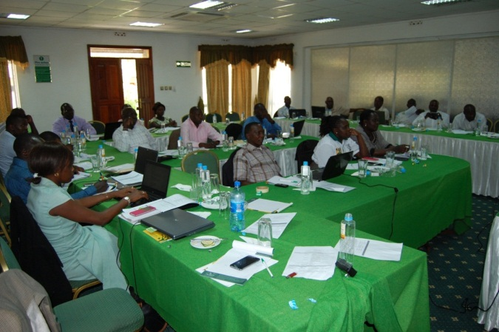
County DRR Platform Training session in Baringo County
- Strengthen and facilitate the DRR platforms’ at County Level
To address the capacity gaps identified by the assessment exercise carried out in the 13 Counties, above the project supported the strengthening and establishment of DRR Platforms in 4 Counties. The Counties of Turkana, Tana River, Baringo and Garissa received technical trainings in the area of DRR including the new DRR global framework. From the training the Counties were able to develop County DRR action plan and form thematic working groups based on Sendai Framework priorities for action. The thematic groups would be useful in lobbying and following-up of agreed actions including reporting on DRR achievements at County level and resource mobilization for a sustainable County Platform for DRR. A total of 91 stakeholders attended the trainings.
- Facilitate/Establish a Coordination mechanism between the National and County DRM structures
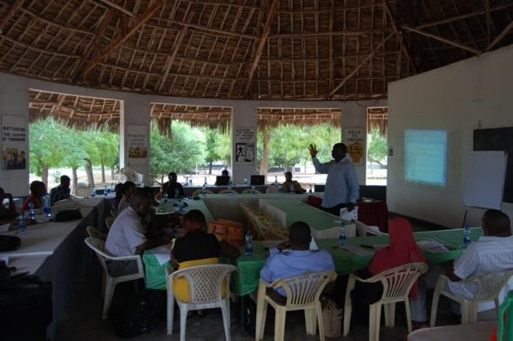
The National DRR platform members offering technical assistance to County DRR platform
To create linkage between the National and County DRR Platforms, the National DRR platform members built the capacity of the County DRR platforms by offering technical trainings on the Sendai Framework of Action and forming of thematic working groups based on Sendai framework priorities for action areas.

Output 2: Capacity to assess and monitor disaster risks and early warning systems strengthened
Under this output the project implemented activities aimed at supporting the government to enhance its capacity for risks assessment and analysis as well as ensuring an effective early warning system is in place. The activities implemented during the year are summarized below:

Activity Result 2.1 Strengthen Risk Assessment and Analysis
    - Support most at Risk counties to undertake Risk and Vulnerability assessment& Strengthen EWS and preparedness & dissemination of Risk Information
In order to ensure that disaster risk reduction measures are based on sound identification and assessment of the hazards and risks that people face, the project in collaboration with Regional Centre for Mapping of Resources for Development (RCMRD) undertook risk assessments and analysis for 3 identified counties. From the assessment, the project developed hazard atlases and climate risk profiles for; Garissa, Tana River and Turkana. County stakeholders who include institutions, policy and decision makers, development and humanitarian partners now have a tool which will enable them to design and implement risk reduction and mitigation measures before during and after disasters. The maps will also contribute to the integration of disaster risk management measures into development policies, strategies and plans. A total of 81 county stakeholders participated in the assessment.

Output 3: DRR Mainstreamed in Key Government Policies, Strategies and Programmes
Develop the DRR Mainstreaming Guidelines and Tools:
The Disaster Risk Reduction (DRR) mainstreaming guidelines were developed to enhance capacity of DRR practitioners and officials working at both County and National Governments, the manual will facilitate discussion and the exchange of ideas in order to develop common understanding of/and identify approaches for the mainstreaming of DRR into development planning processes at all levels. It is envisioned that the guide will help enhance practitioners’ capacity and also provide opportunities to integrate DRR into any sector; or into any programme or project in development planning. The guidelines will be ready for distribution to the various stakeholders by early 2016.
Activity 3.3 Monitor the implementation of MTP II DRR Priorities
3.3.1 Support NDMA in the coordination and implementation of Ending Drought Emergencies DRR Component
During the period under review, the project in collaboration with the UNDP Global Policy Center supported NDMA in the coordination and implementation of the EDE by the formation of the EDE Technical Working Group (TWG) which provided leadership in the implementation of the various EDE pillars. Following the successful formation of the TWG, it received technical support to develop the EDE M&E framework. With the finalization of the EDE M&E framework at National level, selected pilot counties of Turkana and Baringo were assisted to develop result based M& E framework with links to the CIDP and the EDE pillar priorities. Final M&E framework for the Counties of Baringo and Turkana will be published by end of the year. A total of 280 participated in all the four EDE workshops held at both the National and at County Level.
Output 5: Partnerships and Networks for DRR strengthened:
Activity 5:1 Support the government to participate in global DRR discussions (Post 2015 HFA)
The project supported 2 senior Government officials to participate in the World Conference on Disaster Risk Reduction (WCDRR) which was held in Sendai Japan. From the conference, the various heads of State and Government present assessed and reviewed and considered the experience gained under the implementation of HFA 1 2005-2015. From the review, the governments, declared their determination to enhance efforts to strengthen disaster risk reduction to reduce disaster losses of lives and assets worldwide and adopted the Sendai Framework for Disaster Risk Reduction 2015-2030. Following the conference, the project has supported the follow-up in-country activities that operationalize the new framework such as the strengthening of the National and County DRR platform which have been trained on the Sendai Framework for Action.

Activity 5:4 Support the Annual Symposium and International DRR Day:
The National Symposium brought together approximately 100 key stakeholders in DRR including policy makers, development planners, government ministries, researchers, academicians, DRR practitioners, development workers and Non-governmental organizations with interest in DRR to share knowledge.

Highlights of the Symposium
- To have a strategic networking partnerships (through the creation of a portal) so as to facilitate DRR Policies and also work closely with policymakers/parliamentary DRR caucus.
- Have a political desk for DRR to be responsible for lobbying of politicians to support DRR such as formulation and implementation of DRM policy
- Encourage participation of the County Governments in future national symposium through Council of Governors.
- Encourage County to County Symposiums

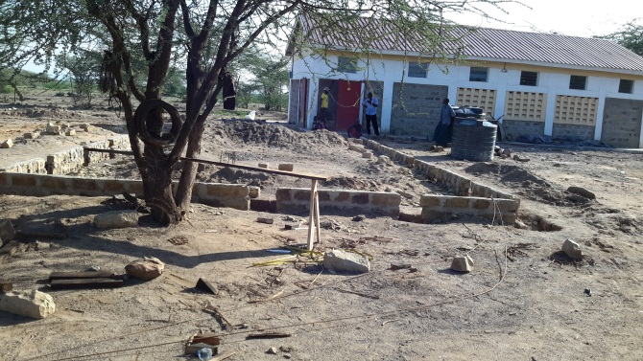

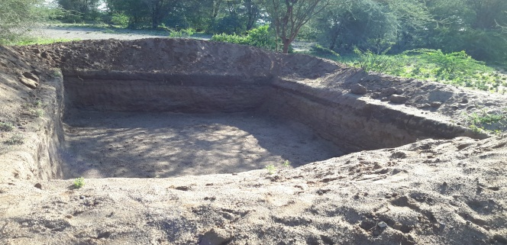

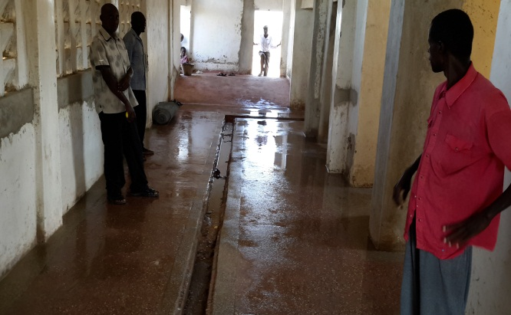
Ongoing additional construction works at the Kakauma Slaughter House

Output 6: Resilience building through diversification of livelihoods for drought affected communities
Under this output the project supported activities that scale up and build on achievements from previous livelihood initiatives with a specific focus on development of value chains and access to markets. The activities implemented during the year contributed to creating long-term employment among the disaster prone communities as summarized in the section below:

Activity Result 6 Development of Livestock Based Value Chains
6.1Completion and Operationalization of the Slaughter House in Kakuma
The Department of Veterinary Services carried out an assessment to advice on the additional works that are required to operationalize the slaughter house in Turkana. After the assessment and the finalization of the report on the required additional works, procurement for a contractor to complete the slaughter house was carried out. Additional construction works to operationalize the slaughter house are currently underway and it is anticipated that the additional works should be complete and slaughter house operationalized by end of the first quarter in 2016. Additionally the project will support the drilling and equipping of a solar powered borehole which will supply the slaughter house with a clean and safe source of water. On completion, the slaughter house will handle approximately 125 small stacks, handle meat hygienically and also create employment for the local community.

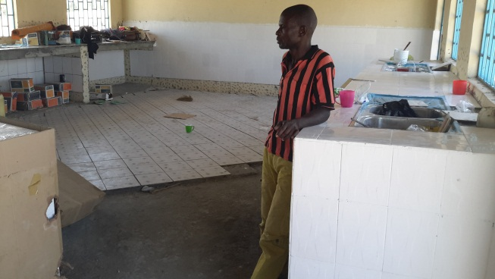
On going works at the Fish Banda
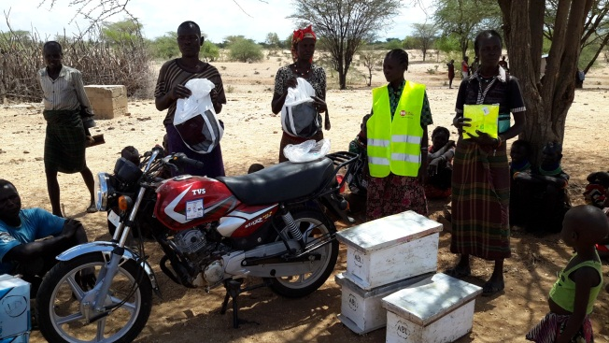Bikes for community groups to market local products
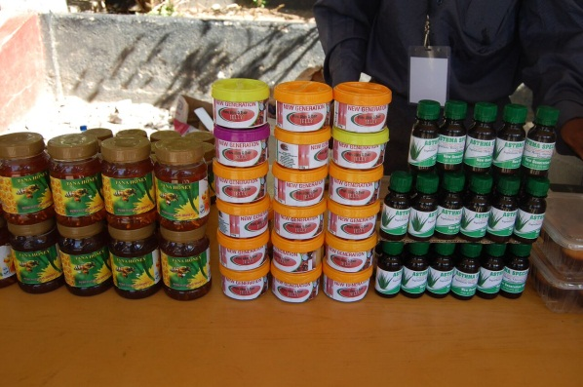
Value added products from Honey
6.2 Operationalization of the Tannery and Leather Utilization Unit:
In partnership with the Kenya Leather Development Council (KLDC) the project carried out an assessment on the requirements to operationalize the rural tannery and leather utilization unit. From the assessment report produced, the project is supporting additional construction works within the tannery, and operationalizing the tanning drum. On completion of the physical structures of the proposed rural tannery and leather utilization units, the tannery and leather utilization unit will be fully equipped with machinery, accompanying chemicals and raw materials to start out immediate operation. This will ensure commencement of processing and value addition of leather thus improving on the socio economic status of the beneficiaries.
The additional works is still ongoing and by the end of the 1st quarter 2016 the rural tannery should be operational complete with a stand by generator. KLDC will provide additional technical support to the tannery by offering on the job capacity building to the community members that will be working at both the tannery and the leather utilization unit.

Activity result 6.2 Development of fish value chains:
Fishing in Lake Turkana provides an alternative livelihood for the local communities and it also reduces dependence on livestock production only which is often seriously affected by drought. To ensure proper handling, storage of fish and to improve on the fish drying technology at the beach, the project is supporting the operationalization of the fish banda and the construction of solar fish drying shades. An assessment to operationalize the facility was carried out by the County Director of fisheries and the County Works Officer. At the time of reporting the construction works were ongoing and should be complete within the 1st quarter of 2016. On completion of the fish band which will be complete with freezers and the solar fish drying sheds, it is envisioned that the shelf life of the fish will be prolonged thus enabling the local community to fetch a higher price for both fresh and dried fish. To ensure continued partnership between the project and the County Government, and to build the capacity of the local BMU members in entrepreneurial skills, the fisheries department through the support of the Turkana County will offer entrepreneurial training to the Kalokol Beach Management.

Activity Result 6.3 Develop Honey Value Chain
6.1 Scaling up of honey production groups
In order to scale up the production of honey 20 local community members received training in establishing and managing viable bee keeping enterprises in ASAL areas. The skills gained from the training included;

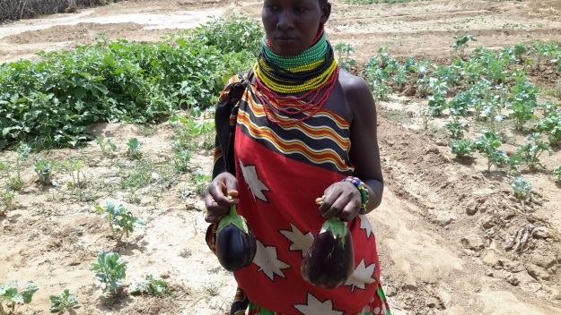
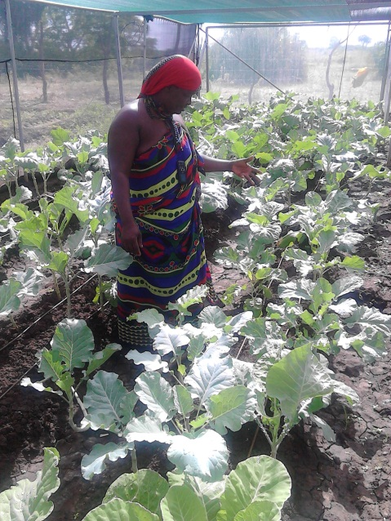
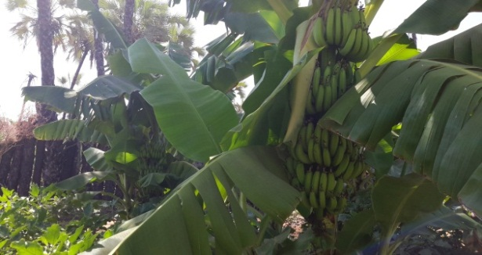
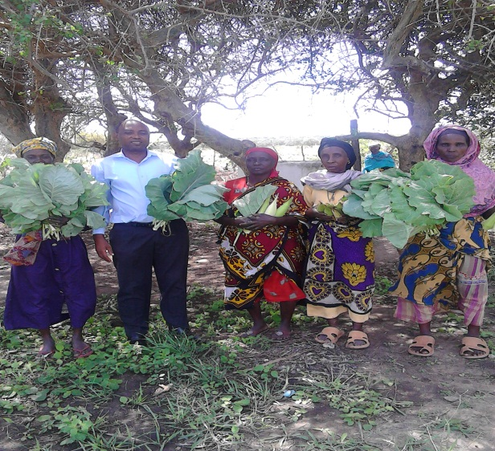
Produce from the irrigation schemes and shade nets
apiary and bee management, value addition and marketing bee products. As a result of the training, the groups now have a local talent pool which can support other community members engaged in bee keeping. The groups have also now diversified value addition to include wax-based lotion, wax sheets and soap.
The project also expanded the number of honey processing groups from 8 to 12 and at the same time increased the bee keeping equipment by 140 langstroth hives, wax sheet making machine and an oil press machine which are used to produce wax sheets and virgin coconut oil which have a high market value. The groups have also been able to increase their production of honey and they were able to harvest over 1225 kg of honey in the last session. With the increase in production, the project supported marketing of the local products by providing 10 motorcycles that are to be used by the local communities to transport the locally produced products to the market. In Tana River County, the community groups have taken up to marketing their products as one unit, the motor bikes are used to collect the honey from the various groups deliver it to one central place and later take it to the market. From the sale of the honey one of the groups has been able to purchase a communal piece of land. The group has also been making langstroth hives which will assist in boosting the numbers of hives within the community and raise honey production. The honey producing groups have also been able to exhibit their products during the 3rd national symposium on DRR.
Activity Result 4 Facilitate Market Development for Irrigation Farmers
Facilitate the formation and Capacity building of farmers
In order to improve food security and provide alternative livelihoods to pastoralists the project supported the local communities to start horticultural production using shade nets and drip irrigation. Shade nets were provided to four community groups and with the support of the Ministry of Agriculture, the communities have been able to plant tomatoes and kales in the four shade nets.
In addition 20 selected members of the beneficiary groups were trained on improved farming technology course. From the trainings, the farmers have acquired new skills in; soil and water management, suitable dry land crops, food preservation and value addition to agro-produce.
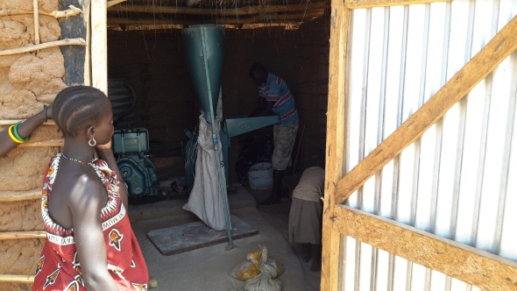
Posho Mills in the irrigation scheme
In addition, the Nawoyawoi irrigation scheme which is approximately 200 hectares, was supported with maize, sorghum, green grams and cowpeas seeds. Within the scheme members have set aside a vegetable and fruit orchard where they have planted bananas, egg plants and kales. Farmers have been able to harvest the vegetables and bananas which they use at household level to improve the nutritional status of their families and also sold the surplus to gain some income. This will have a lasting impact as it will enable the communities to diversify from pastoralism which is prone to natural disaster shocks.
Through the Ministry of water and irrigation, the project also carried out an assessment at the Kanaodon Irrigation Scheme to determine the irrigation infrastructure required to operationalize the scheme. The actual construction of infrastructure which was to start off in the forth quarter was interrupted due to the rains experienced within the area. Works will commence immediately the rains subside and it is envisioned that the farm should be operational by the end of the first quarter 2016.
In order to support the farming groups to add value to the produce from their irrigation farms, the project supported the 2 farmer groups In Turkana County the two irrigation groups which benefitted from the activity will utilize the mills to mill the maize they plant in their farms and thus sell it to the local market as flour
Scaling up of Livelihood activities:
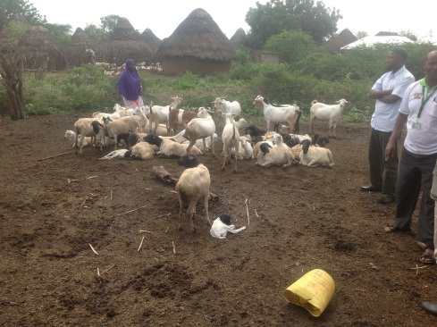Galla Goats in Garsen Tana River County
Breed Improvement in Tana River
From the previously implemented Enhanced Resilience Project, 5 local community groups (125 households) were supported improve their stock through better breeds. To upscale on the previous 20 galla goats, each group was given an additional 15goats. The communities now are able to get higher meat and milk production. With the improved breeds, the communities are able to sell the goats at a higher price in the market compared to the local breeds.
Promotion of Agro- value chains and value addition of farm produce:
In Tana River 5 women groups were supported with posho mills complete with hurlers. The groups utilize the mills for their own grown produce as well as purchased produce such as green grams and beans. Once the various legumes and maize is milled they produce fortified flour which they will sell to the local market as a form of Income generation. In the long-term this diversification will result in more resilient households. The groups use the income generated from the posho mills to support the education of the girl child among their community. They currently have slightly above 16 girls who they are supporting with school fees.

III. CHALLENGES
During the quarter, the project faced some challenges which affected the implementation of activities. These challenges are summarized below:
- Administrative challenges: The project has been running on very lean staff.
- Insecurity: there were isolated cases of insecurity in Turkana County along the Turkana - Kapenguria Road. This led to a delay in the delivery of materials equipment to the beneficiary communities.

IV. LESSONS LEARNT SO FAR
Implementation through partnerships: Implementation through partnerships with private sector and other specialized agencies have enabled the project to leverage on the technical skills available within partner organizations.

V. PROJECT MANAGEMENT
- Project Management
During the reporting period, NDMA continued to provide project management with support from UNDP quality assurance team. During the quarter, 4 PSC meeting was held which provided guidance to project implementation and policy issues. In addition, 8 monitoring visits with the project team and 1 monitoring visit by the PSC. The field visits ensured that quality of implementation was high and provided corrective action were necessary. This visits also spot checked of financial diligence at field level to ensure efficient use of resources.

VI CONLUSION
Local communities already have results to show for the activities being carried out during this year. In future years, impact of the activities will be evident among the local communities as their resilience towards disasters is built.

Draft maps are available on: https://www.dropbox.com/s/l18r2jsch4nvigt/GARISSA%20ATLAS%20%281%29.pdf?dl=0 https://www.dropbox.com/s/tniycxdgjtlq8bz/TANA%20RIVER%20%20ATLAS.pdf?dl=0 https://www.dropbox.com/s/f8uil2qucvmw0mp/TURKANA%20ATLAS%20FIRST%20DRAFT%20%284%29.pdf?dl=0
Finalized reports are on: https://www.dropbox.com/s/x8r3cj50phk23by/2nd%20EDE%20ME%20TWG%20Worskhop%20Report%20-%20Final%202nd%20Dec%202015%20%282%29.pdf?dl=0 https://www.dropbox.com/s/ptuo63bqlcz3euq/EDE%20ME%20Consultative%20%20Worskhop%20Report%20-%20Final.pdf?dl=0
Symposium Report is available on: https://www.dropbox.com/s/dhw70d2yigkv0xs/Third%20National%20Symposium%20Report%20Jan%205%202016%20%282%29.pdf?dl=0
1Kg of honey sell for Ksh.600 at the local market

